**ASSIGNMENT 5.2**

**Problem Statement:**

● A Fibonacci series (starting from 1) written in order without any spaces in between, thus producing a sequence of digits.

Write a Scala application to find the Nth digit in the sequence.

○ Write the function using standard for loop

○ Write the function using recursion

**Write the function using standard for loop**

**Scala code:**

Below code calculates nth digit in Fibonacci

* Program will prompt for the input
* And reads nth to be found in the sequence from console
* And calls the fib_series function to calculate fibonacci series for n and nth digit with for loop
* For loop will add the previous and current number untill n-1
* Appends the Fibonacci number to sequence with StringBulider
* And displays the sequence
* Sequence.charAt(n-th digit) will display number at that position





**Result:**

Program prompted for digit to be found.

And displays Fibonacci sequence and nth number(6765) and **nth digit (2)(which is required)**





**ii) Write the function using recursion**

**Scala code:**

Below code calculates nth digit in Fibonacci

* Program will prompt for the input
* And reads nth to be found in the sequence from console
* And calls the fib_recur function itself recusively to calculate fibonacci series until n-1
* Appends the Fibonacci number to sequence with StringBulider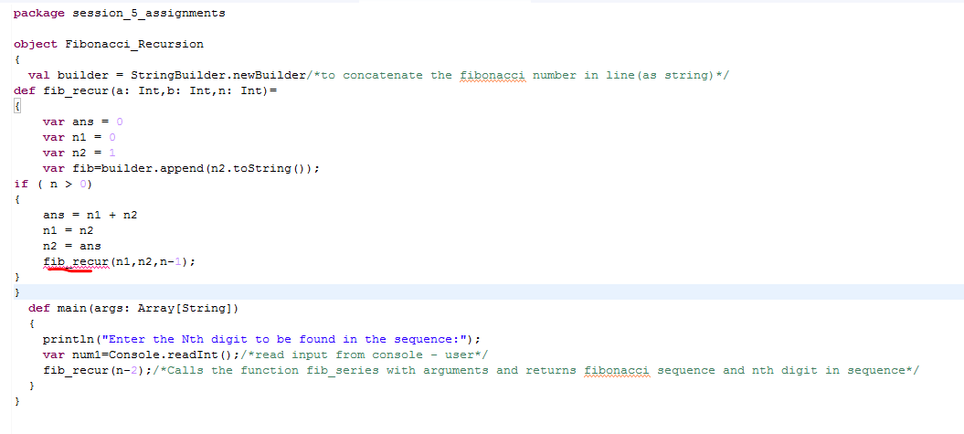

**Result:**

Program prompted for digit – 5 to be found.

And displays **nth digit (5)(which is required)**

